Student’s Individual Study #4

Full Name: Izteleuova Arailym
Educational Program: Linux for DevOps

Topic: Working with Services

Target: Create and configure Linux services, containers, and scheduled scripts.

1. Statement
This SIS focuses on working with Linux services, Docker containers, and automation using cron jobs.
The goal is to create, configure, and test services running inside a Docker container and ensure automatic restarts and scheduled maintenance tasks.

2. Step-by-Step Report

Step 1 — Verify Docker installation

Step 2 — Create Flask application Installation was done using both apt and pip package managers.
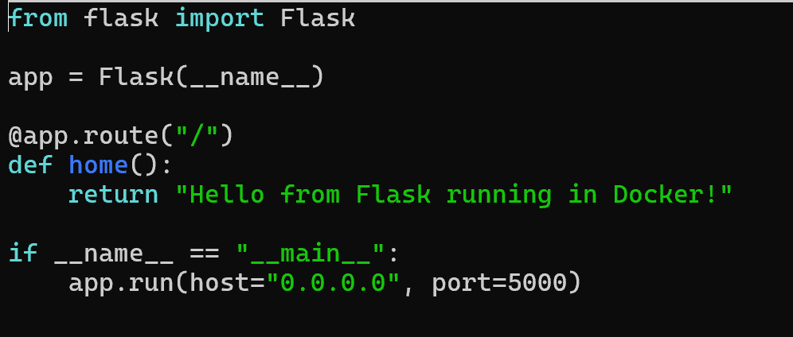

Step 3 — Create Dockerfile

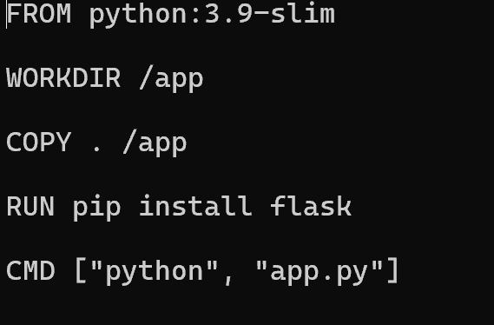

Step 4 — Build Docker image
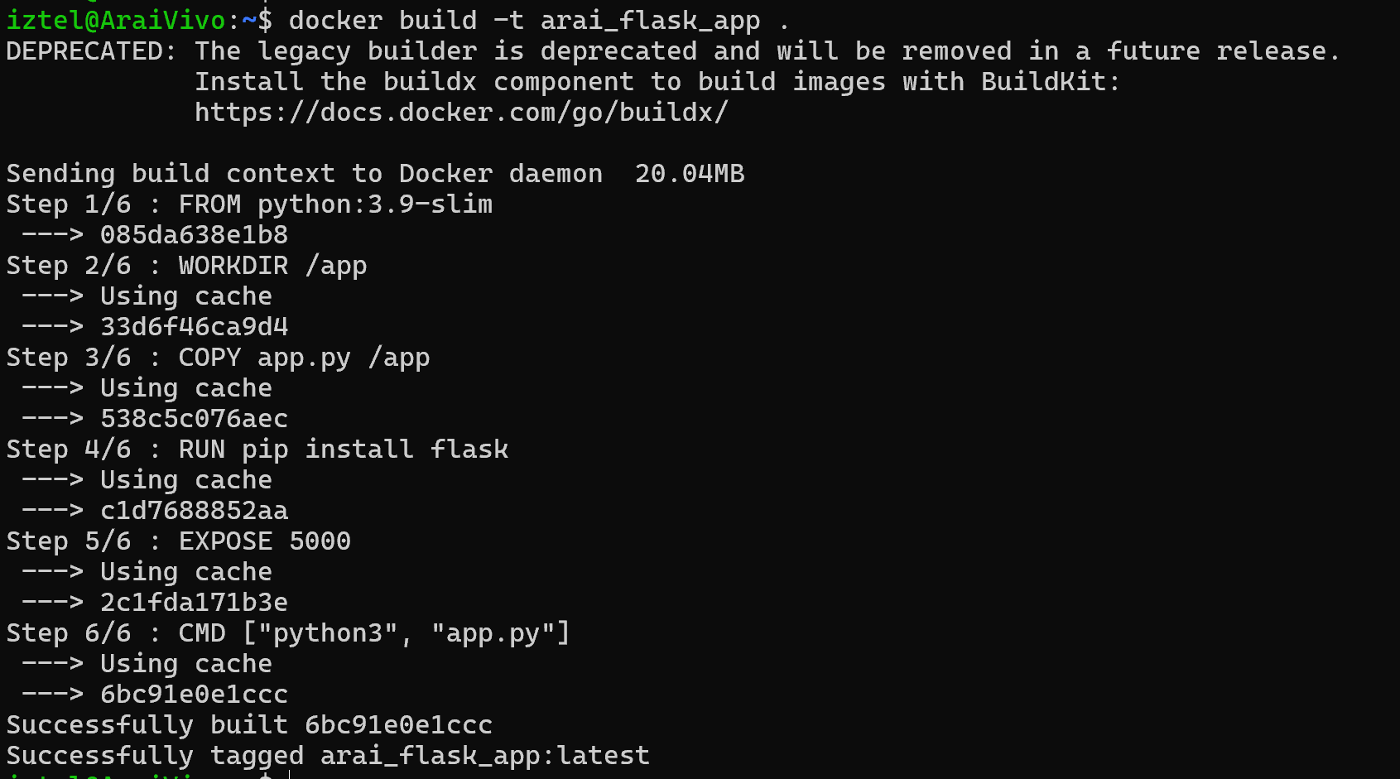

Step 5 — Check if image exists
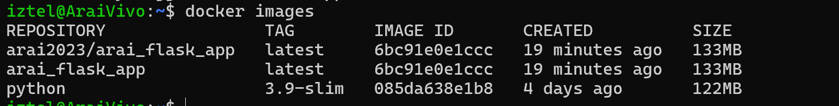

Step 6 — Run the Flask container
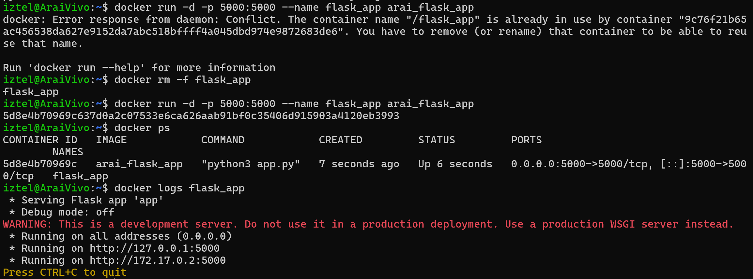

Step 7 — Check logs to confirm the app is running
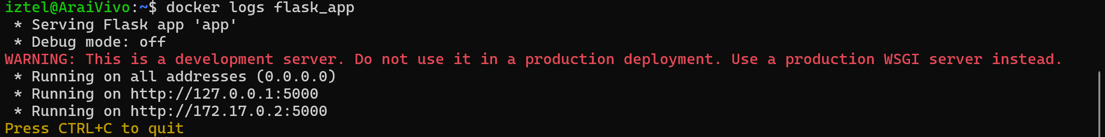

Step 8 — Test application in browser
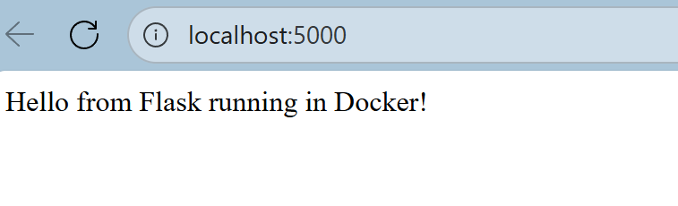

Step 9 — Login into Docker Hub
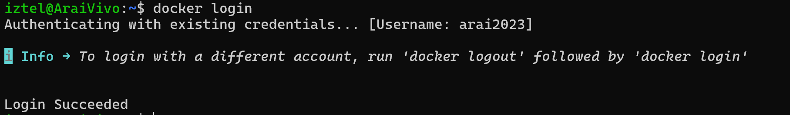

Step 10 — Tag the image for Docker Hub

Step 11 — Push the image to Docker Hub
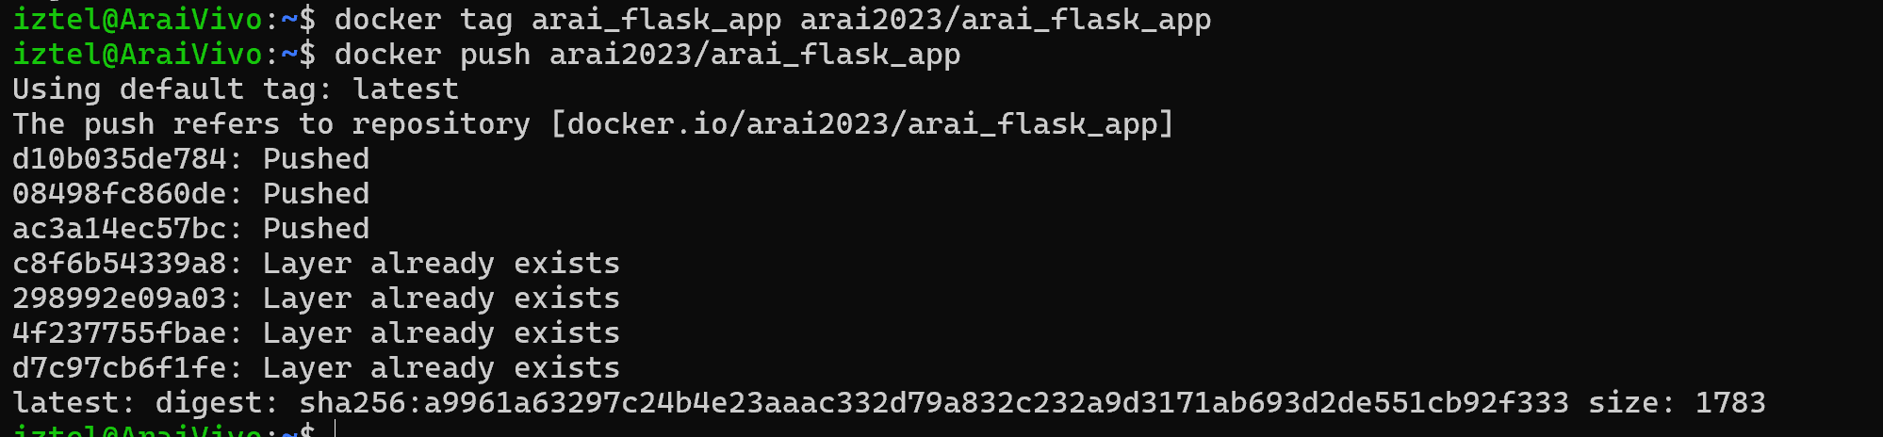

Step 12 — Pull and run image from Docker Hub to verify deployment
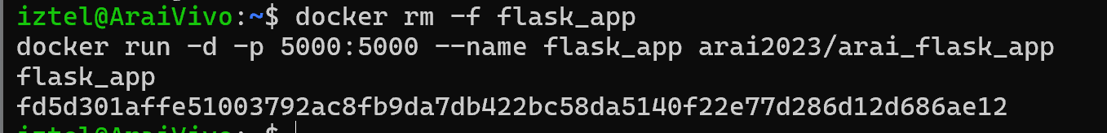

Conclusion
During this lab, I successfully:
- Created a Flask web application
- Built a Docker image using a Dockerfile
- Ran the application in a Docker container
- Pushed the container image to Docker Hub
- Pulled the image from Docker Hub and deployed it again

3. Repository Link
All scripts and configuration files are available on GitHub:
https://github.com/Arai2023/LinuxforDevOps.git

